Written Print Unit Exam Name_________________
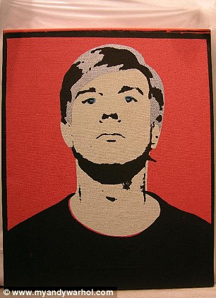 A.
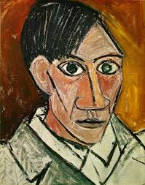 B..
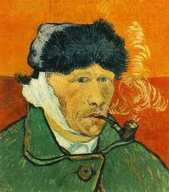 C..
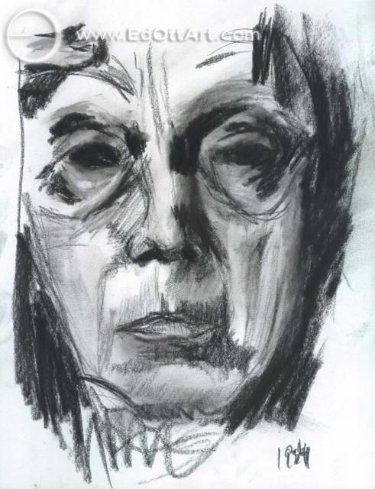 D.
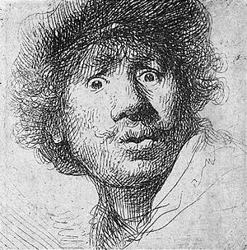 E.

Match artwork to artist
Rembrandt_____

Van Gogh______

Kathe Kollwitz____

Andy Warhol_____

Lucian Freud _____

Salvador Dali_______

Picasso______

Frieda Kahlo____

Albert Durer____

Leonardo Di Vince_____

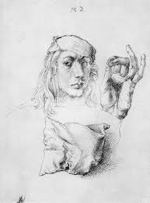 F. 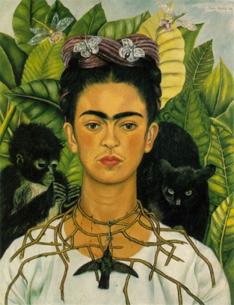 G.

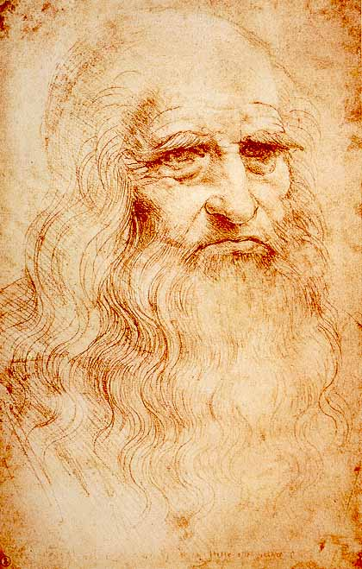 H. 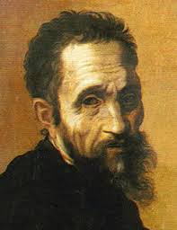 I.

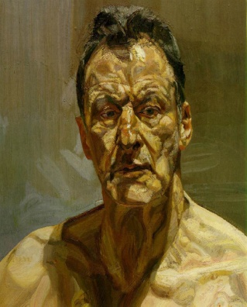 J. 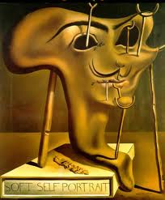 K.

DOCUMENTATION
1) Turn in your photograph of each plate of your self portrait.
2) Describe the process you did on each plate image.
* If you created a blog containing your process and photos give me the URL here

ARTIST STATEMENT ESSAY
Answer these questions in essay form:
Explain the choices you made in creating this piece and why they represent you as an individual.
What do you feel is the most successful?
What were some of the challenges you faced making this piece?
What did you learn about yourself and/or any new information during this process?
Would you say this is your favorite self portrait? Why or why not?

